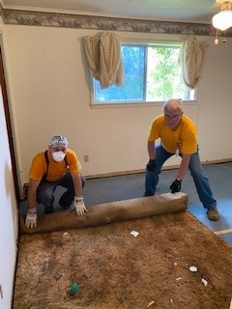

**Southern Baptist disaster relief teams**

**help clean out a home damaged by**

**May flooding in southwest Louisiana**